**EXPERIMENT NO—2,3::TOPLOGIES:**

*Aim :*

**Configuration of topologies using packet tracer**

**(bus,star ,ring, mesh,tree,hybrid)**

*Software/Apparatus required:*

Packet Tracer/End devices, bridge, connectors

**Procedure:**

Steps for building topology:

Step 1: Start Packet Tracer

Step 2: Choosing Devices and Connections

Step 3: Building the Topology – Adding Hosts

Step 4: Building the Topology – Connecting the Hosts to Switches

Step 5: Connect PCs to switch by first choosing Connections

Step 6: Configuring IP Addresses and Subnet Masks on the Hosts

Step 7: To confirm Data transfer between the devices

**STAR TOPOLOGY:**

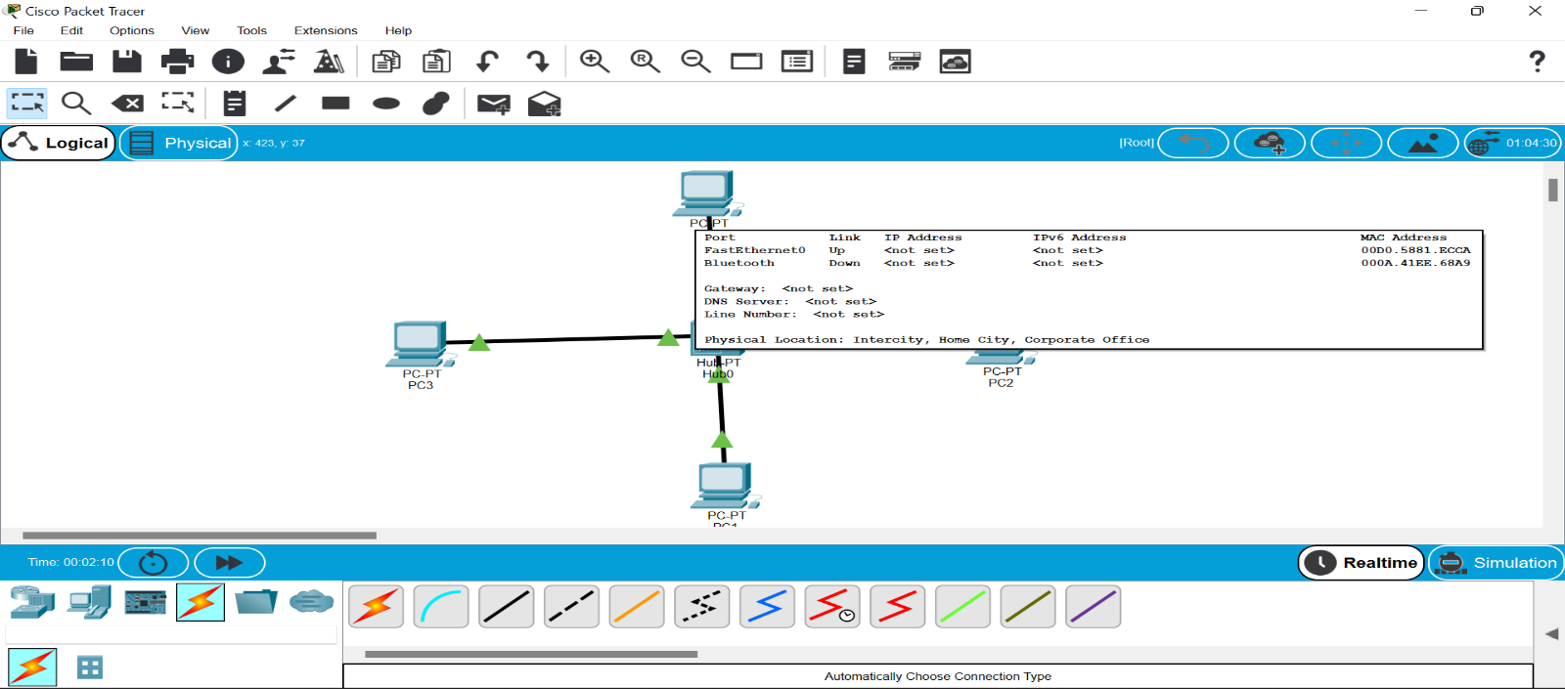

**BUS TOPOLOGY:**

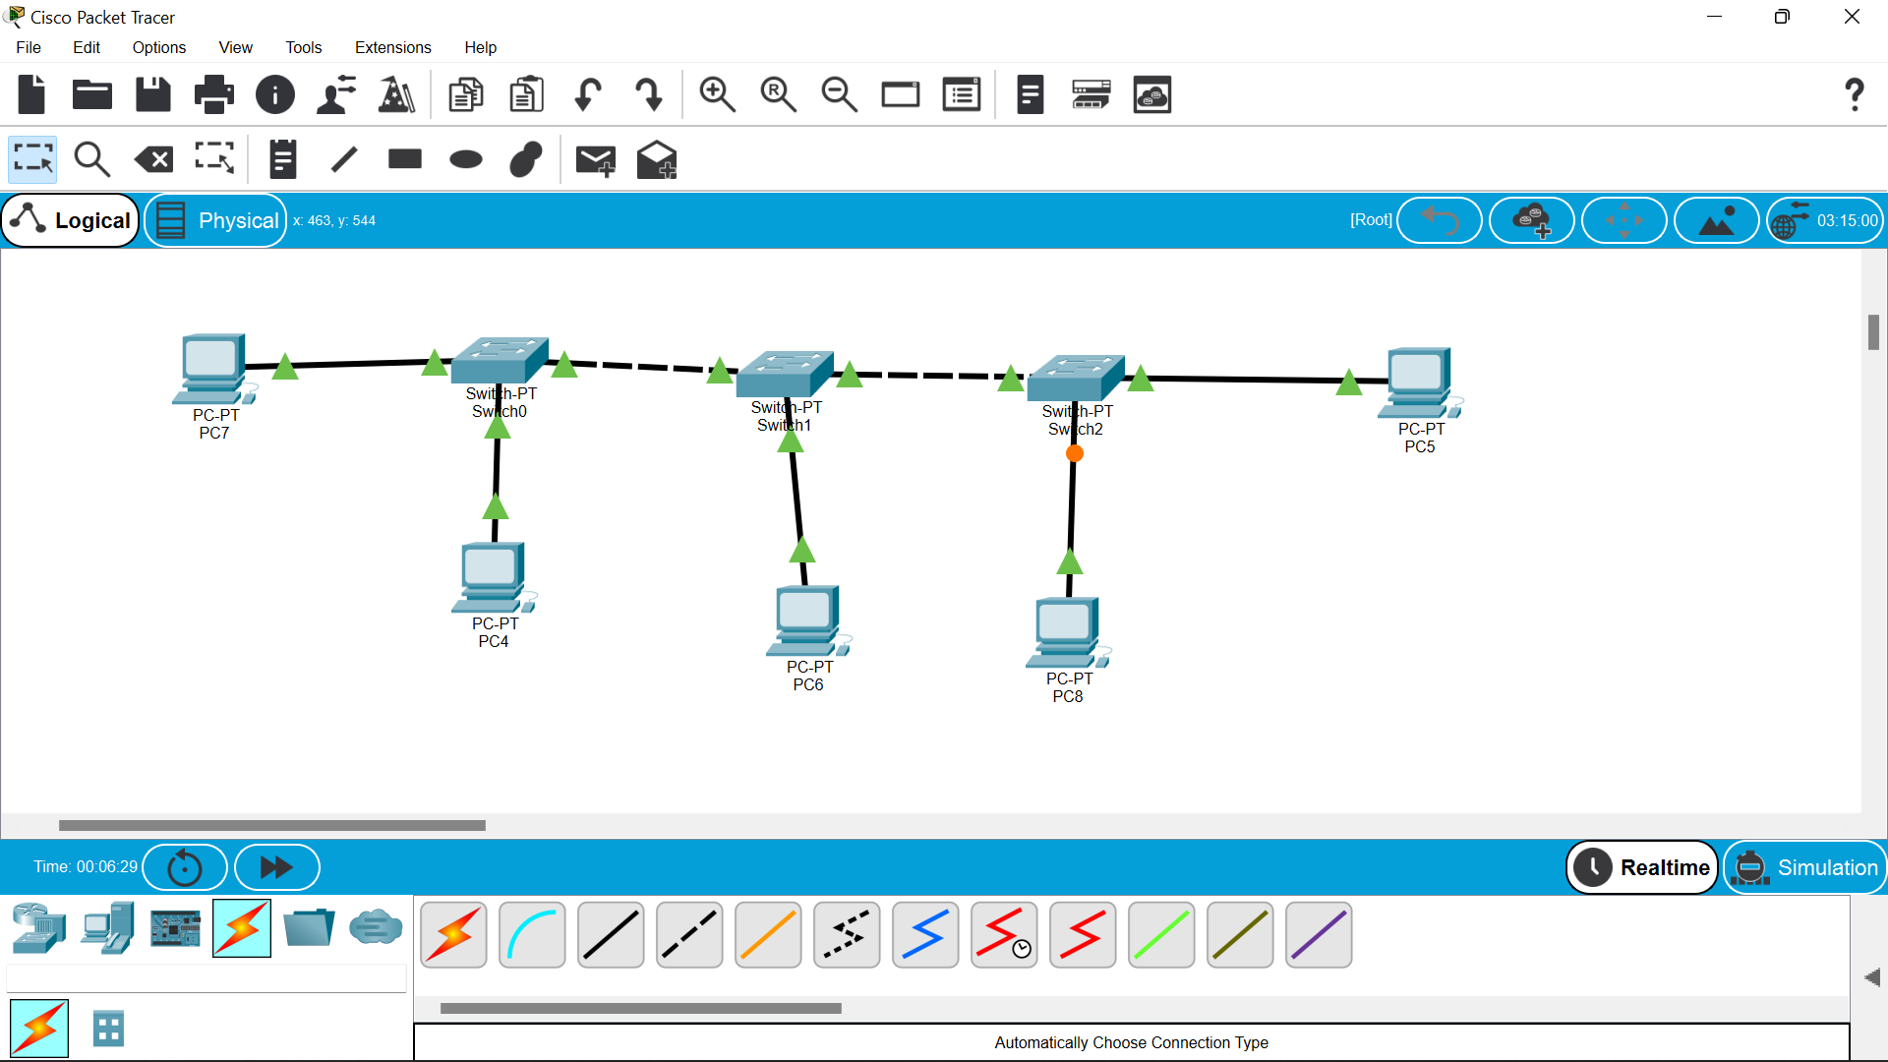

**RING TOPOLOGY:**

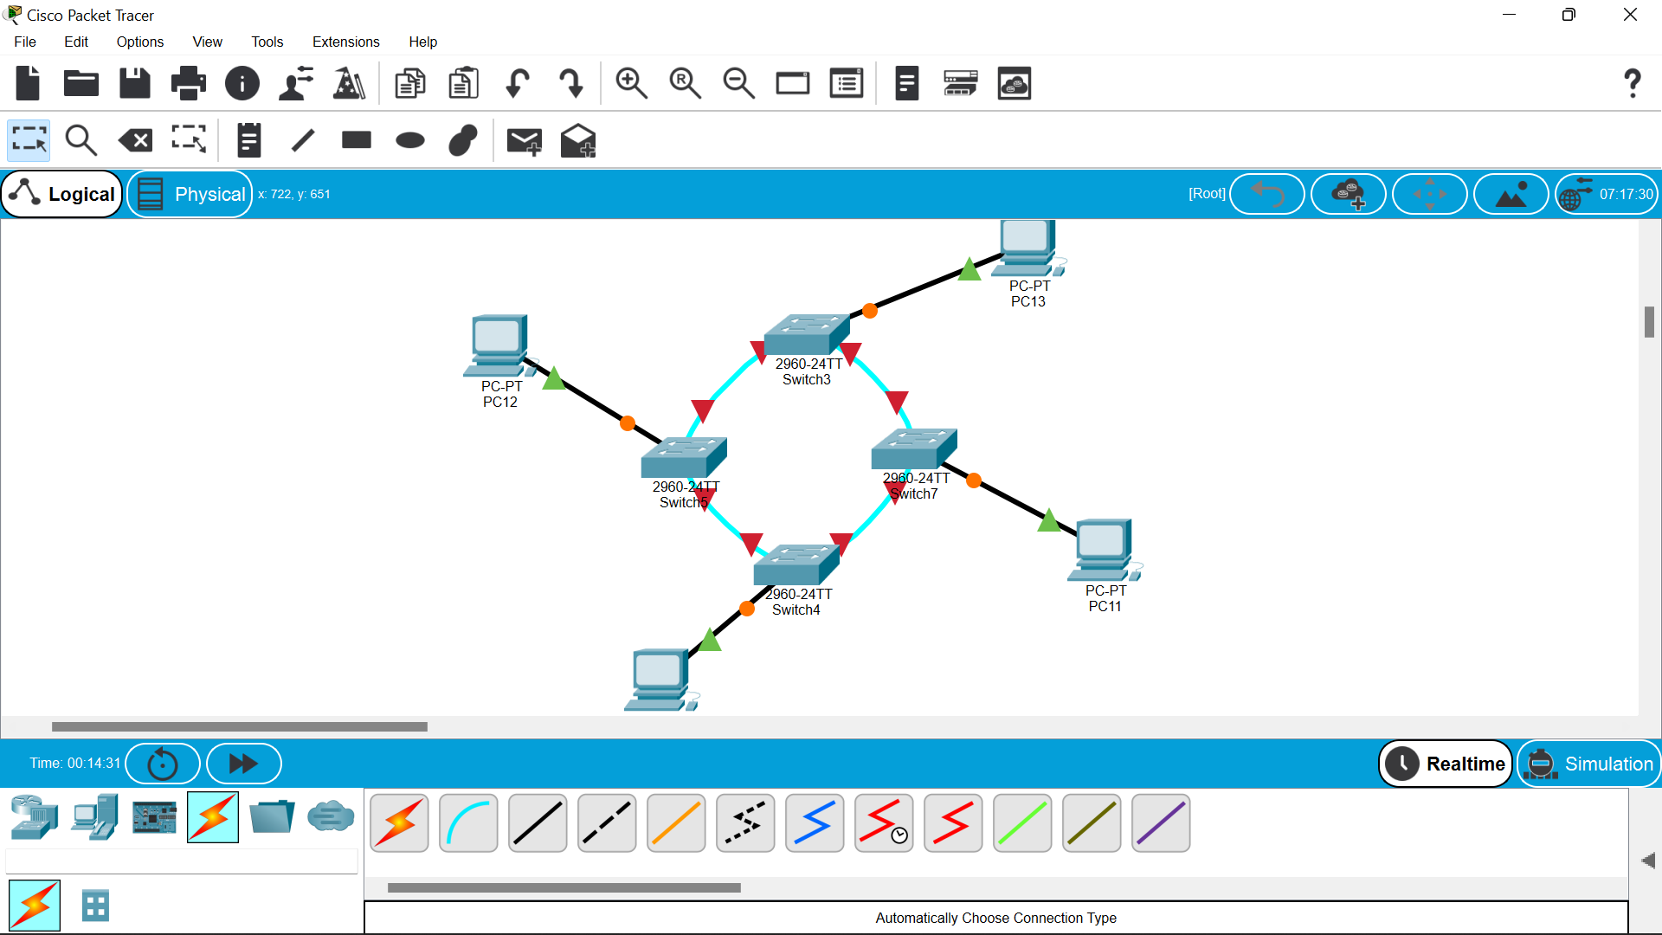

**MESH TOPOLOGY:**

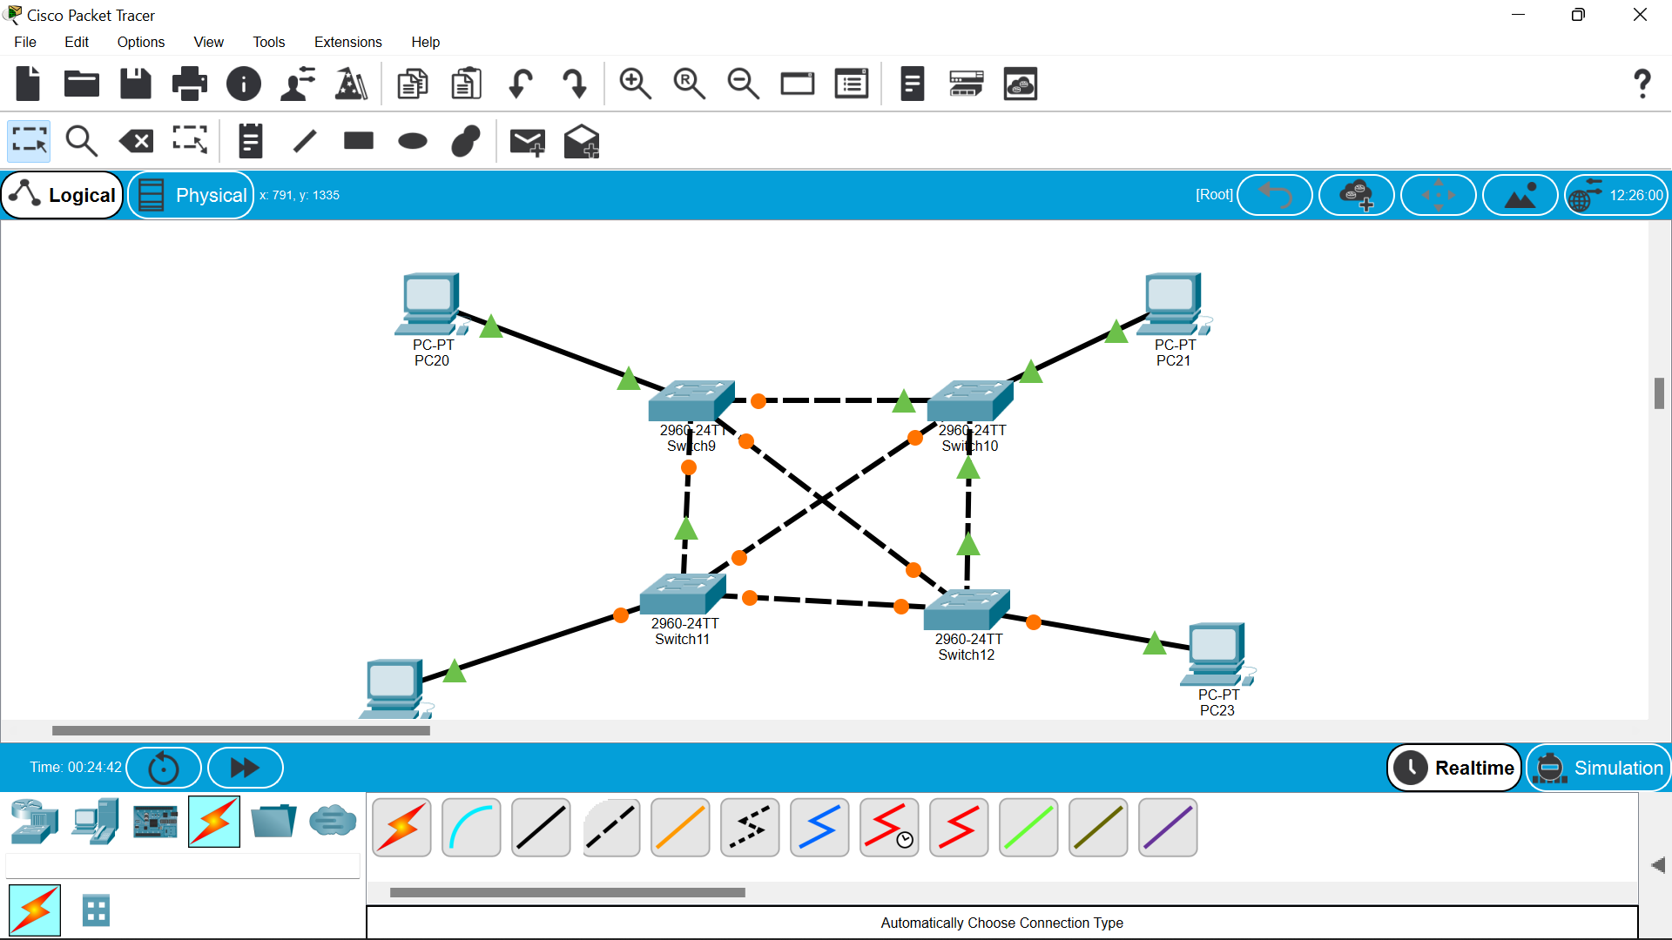

**TREE TOPOLOGY:**

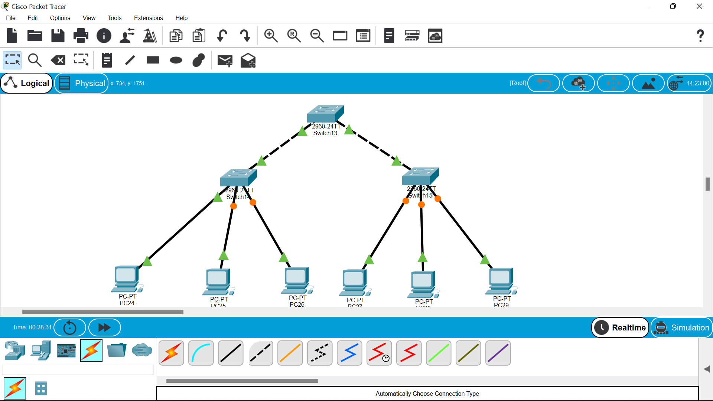

**HYBRID TOPOLOGY:**

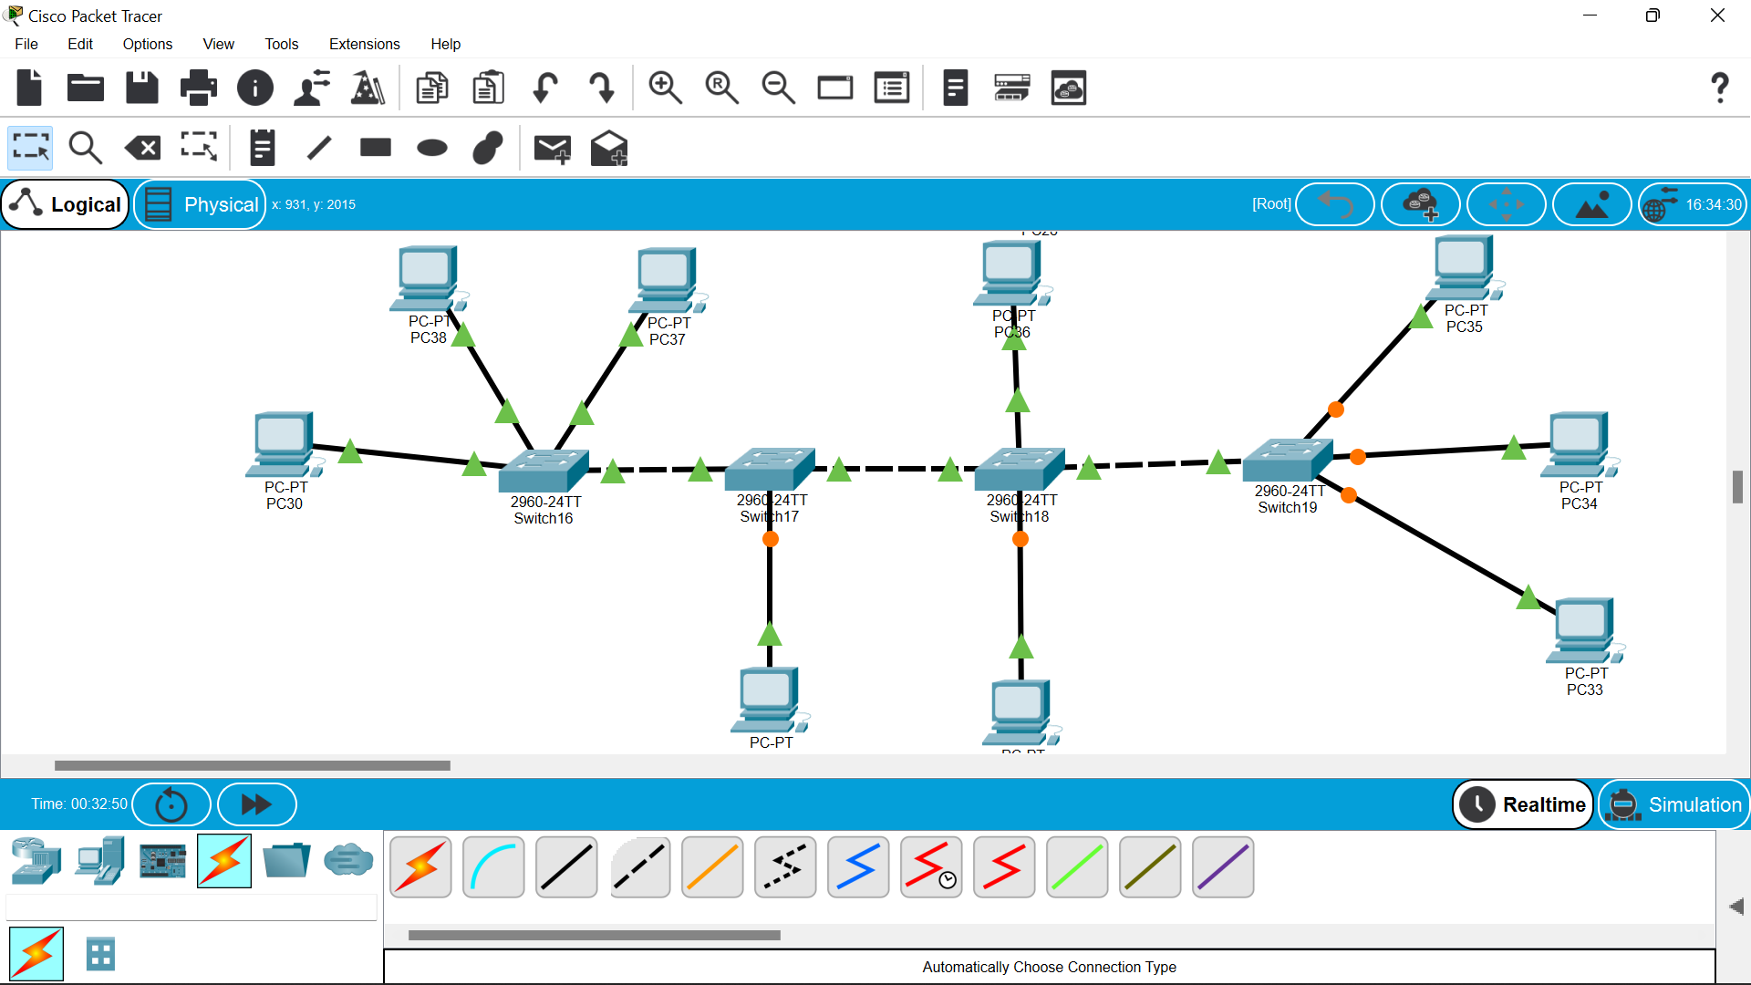

**Result:**

**Thus the configuration of the topologies had been done successfully.**